1. Sadly, my app mostly uses ok http client for connection establishing, so there is not much to check in case of TrustManager.

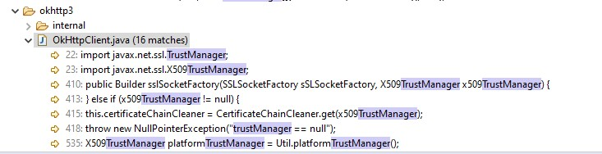

But looking into HostnameVerifier I found some disturbing stuff:

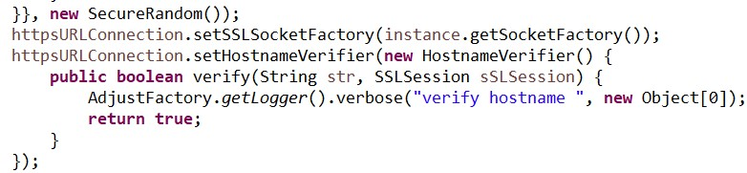

Here is obvious example of “lazy” verification. At least I thought so at first. But then I looked up name of function where this happens.

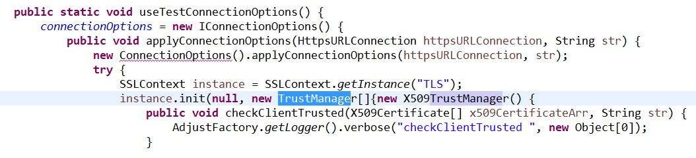

It’s a test function. So basically that is not used in production, if configuration is set up correctly (there is separate class for storing test configuration).

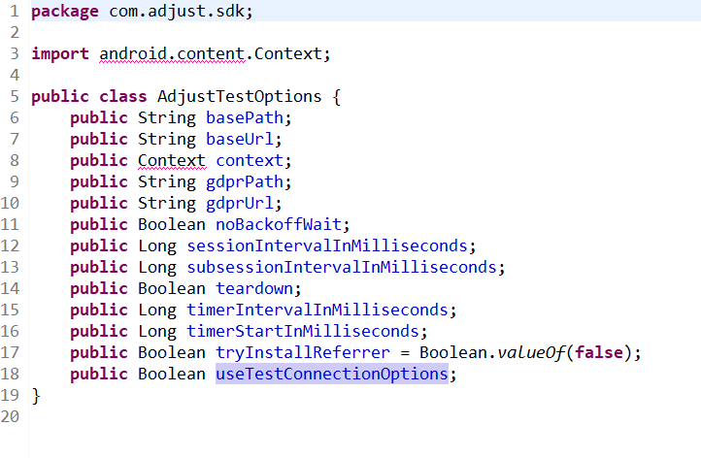

Then I looked into tendcloud SDK (tendcloud is company that offers smart data storages and so on). They obfuscated their code, so going through it was a little hard.

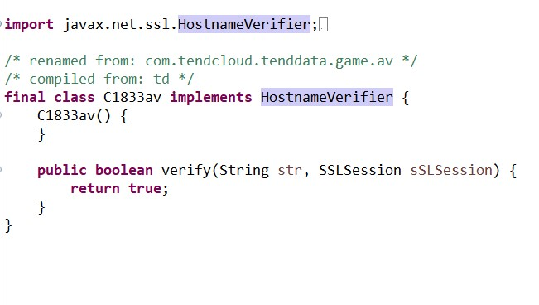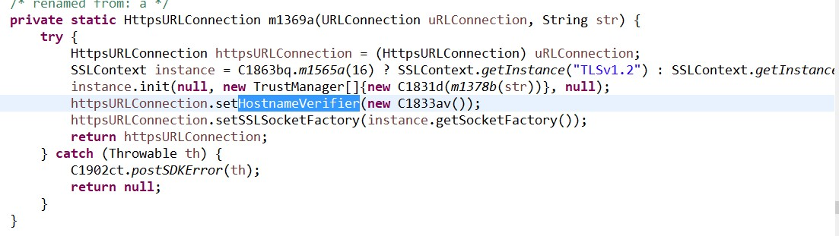

(But there is a clone of it, which uses actual certificate instead of this thing).

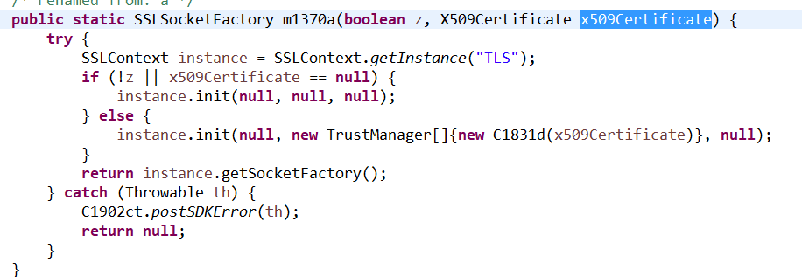

Well, that’s basically it. That’s not a test function for sure. It’s used here.

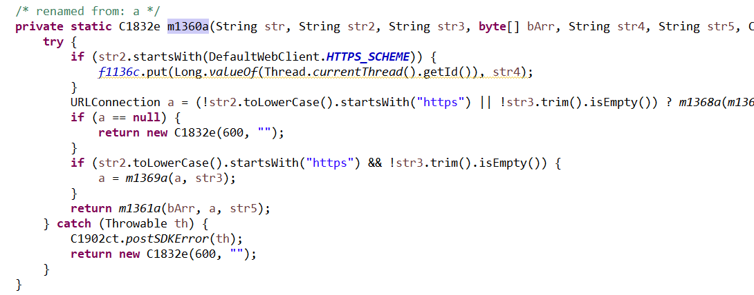

So there may be usage of “lazy” HostnameVerifier in tendcloud SDK.

Also I found some correct usages like in helpshift SDK (sdk for FAQs and user support services).

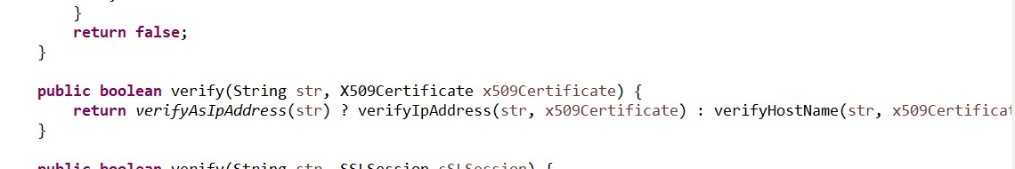

1. Found it!

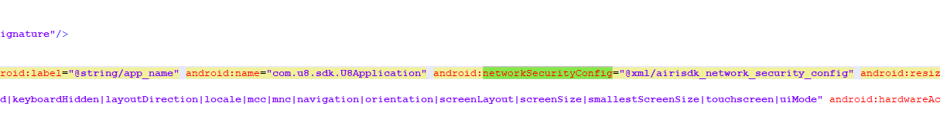

Let’s look what’s inside.

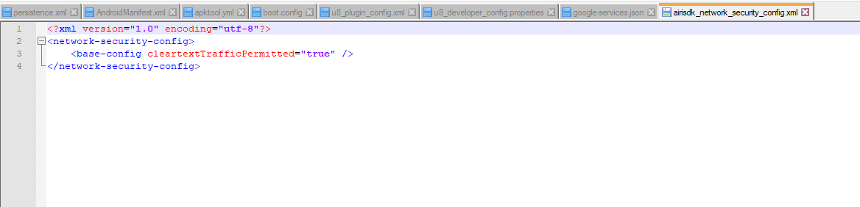

Huh? What’s that? Well, I guess there are no pins here at all.